Marker Plagiarism Check Acknowledgement Form

I, ________ Munish Kumar ______(name of marker), _____ M2090099___ (PI Number) declare that I have reviewed all Turnitin plagiarism reports corresponding to the candidates who submitted answer scripts in the following assessments marked by me in ____ Jul 2021__ semester (Month/Year).

Course Code | Assessment Inspected  (TMA/GBA/ECA/Capstone Final Report)* | Number of Reports Marked in Assessment | Number of Reports Suspected of Plagiarism
ANL488 | Capstone Final Report | 3 | 0
Total Number of Reports Inspected

*You may expand the table if you have more inputs. This form should contain the plagiarism reports of all assessments you have marked in a particular programme.

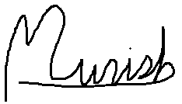

____________________ _________08 Nov 2021____________
Signature of Marker Date

